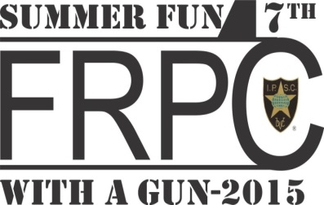
Summer Fun 2015 Registration Form

Match Dates: 18 – 21 June 2015
Registration opens 08:00 hrs daily.
Walkthrough: 08:55, First round: 09:00

Name: _____________________________ Address: ___________________________
___________________________
___________________________
___________________________

Tel # and E-mail address: __________________________________________

IPSC Region/Section: ____________________ IPSC membership number: ___________

Division (circle one)

OPEN CLASSIC STANDARD PRODUCTION STANDARD REVOLVER

Power factor (circle one) Major Minor

Category (circle if applicable) LADY JUNIOR SENIOR SUPER SENIOR

Shooting date preference (1 to 3) : 18 Jun (workers only) ___________
19 Jun ___________
20 Jun ___________
21 Jun ___________

Please squad me with (must send registrations/fees together):____________________________

ROs. I am a certified Range Officer, and available to work (circle preferred dates):

19 Jun | 20 Jun | 21 Jun

Shirt size – Men’s XXL; XL; L; M; S Ladies XXL; XL; L; M; S

Registration fee(s) (@ $135 per shooter) _________________________

Total _________________________

Please Note - No refunds for withdrawals after 4 June 2015
Mail registration, Match Fee(s) to:
(Make Cheque/Money Order payable to: FRPC – Matches)

FRPC – Summer Fun 2014, 2882 Highway 2, Kingston, ON, K7L 0C2

EMT with completed form(s) to funwithagun2015@gmail.com

